9 day Ultralight Flight Training Immersion
Do you have a dream to become an ultralight pilot? This residential on-site package gives you the opportunity to progress your training towards completion of an ultralight pilot permit at our beautiful site on the banks of the mighty Peace River. Training is provided in the high-tech Pipistrel Alpha Trainer ultralight aircraft by a fully accredited, fully insured pilot trainer. Guaranteed 12 hours of in-flight training, with more hours often possible.
Package includes (based on 1 - 2 occupancy):
- First night cocktail reception for 2
- 9 nights of accommodation for 2 in a fully serviced modern cabin on the river bank with full kitchen. For more information on our location and amenities, go to https://peacerivercanada.com/index.php
- Minimum **12 hours guaranteed airplane time for one person (additional hours subject to surcharge)
- Additional 12 Hours guaranteed ground instruction briefings, preflight briefings and post flight debrief, companion is welcome to attend.
- Last night dinner for 2 with trainer, all other meals self-catered

*For the most satisfying experience, and in order to ensure a high chance of obtaining your ultralight pilot permit, it is recommended that ground school training, radio license and pilot medical are completed before attending flight training

**Summer weather in the Peace River region normally promises many days of long, fine, flying-suitable weather. In the event of weather, mechanical issues or instructor availability and in the event the student is unable to fly for any particular reason the flight portion of the cost will be refunded at a rate of $220 per hour for hours less than the guaranteed 12 hours.
More information about the flight training process: https://flyaerosport.com/flight-training-training-steps.php
More information about the flight school and trainer: https://flyaerosport.com/flight-training-crew-and-school.php
For non-flying companions, and in your time off from training, enjoy a selection of outdoor and river activities mixed with local attractions. Available options on site include canoe or kayak paddling, hiking, or enjoying the amenities and venues of the nearby towns in the region, including Peace River (30 km), Grimshaw (16 km). https://mightypeace.com/activities/

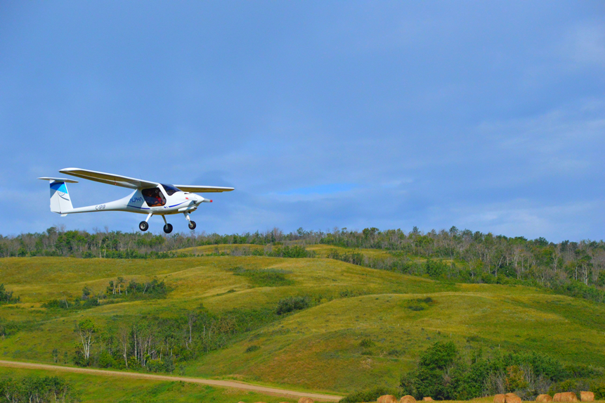
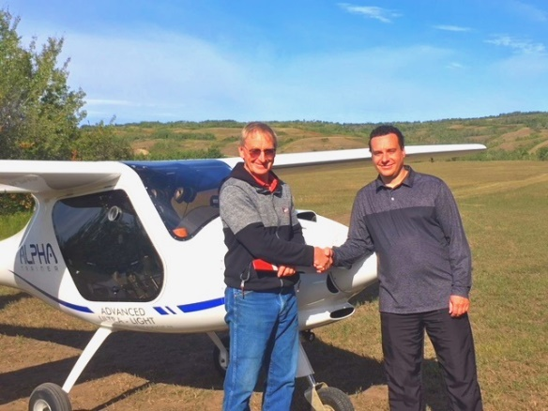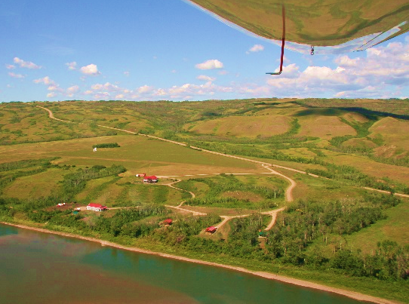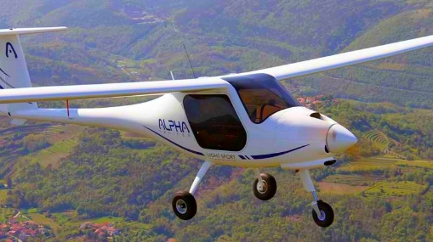
Optional Add- Ons subject to availability:
- First evening meal and first continental breakfast kitchen stocking available @$42 pp
- Additional training hours as agreed on with flight trainer, ROC-A radio license, PSTAR exam, student pilot permit issuance, issuance of ultralight pilot permit available as progress dictates.
- Unlimited hiking or upstream paddling as desired. Additional guided padding $40 /hr., self-guided downstream $10/hr. plus shuttle
- Wood fired hot tub: $200 for 5 consecutive nights including firewood
- Golfing at one of multiple local courses https://mightypeace.com/activity/golfing/
Important policies to note:
- Availability: this package is available May to October.
- Reservation policy: Bookings are only confirmed with receipt of minimum deposit of 50% of invoice. MasterCard, Visa or E-transfer. Balance due at time of check-in.
- Cancellation policy: 30 days prior to stay- full refund of deposit, 29 to 15 days prior to stay, 50% refund of deposit, 14 days and under- full deposit retained.
- For more information on cabin amenities: https://peacerivercanada.com/peace-river-camping-cabin-rental.php
- Rustic Cabin: deduct $438 from 9 night rate https://peacerivercanada.com/peace-river-cottage-cabin-rental-jb-early.php
RATE CAD RETAIL : $5200 plus GST Optional: $250 per hour for additional flying hours.
For more information or to book call Henry (780) 835-1992 or email henryvos1@gmail.com
Website https://flyaerosport.com/index.php

